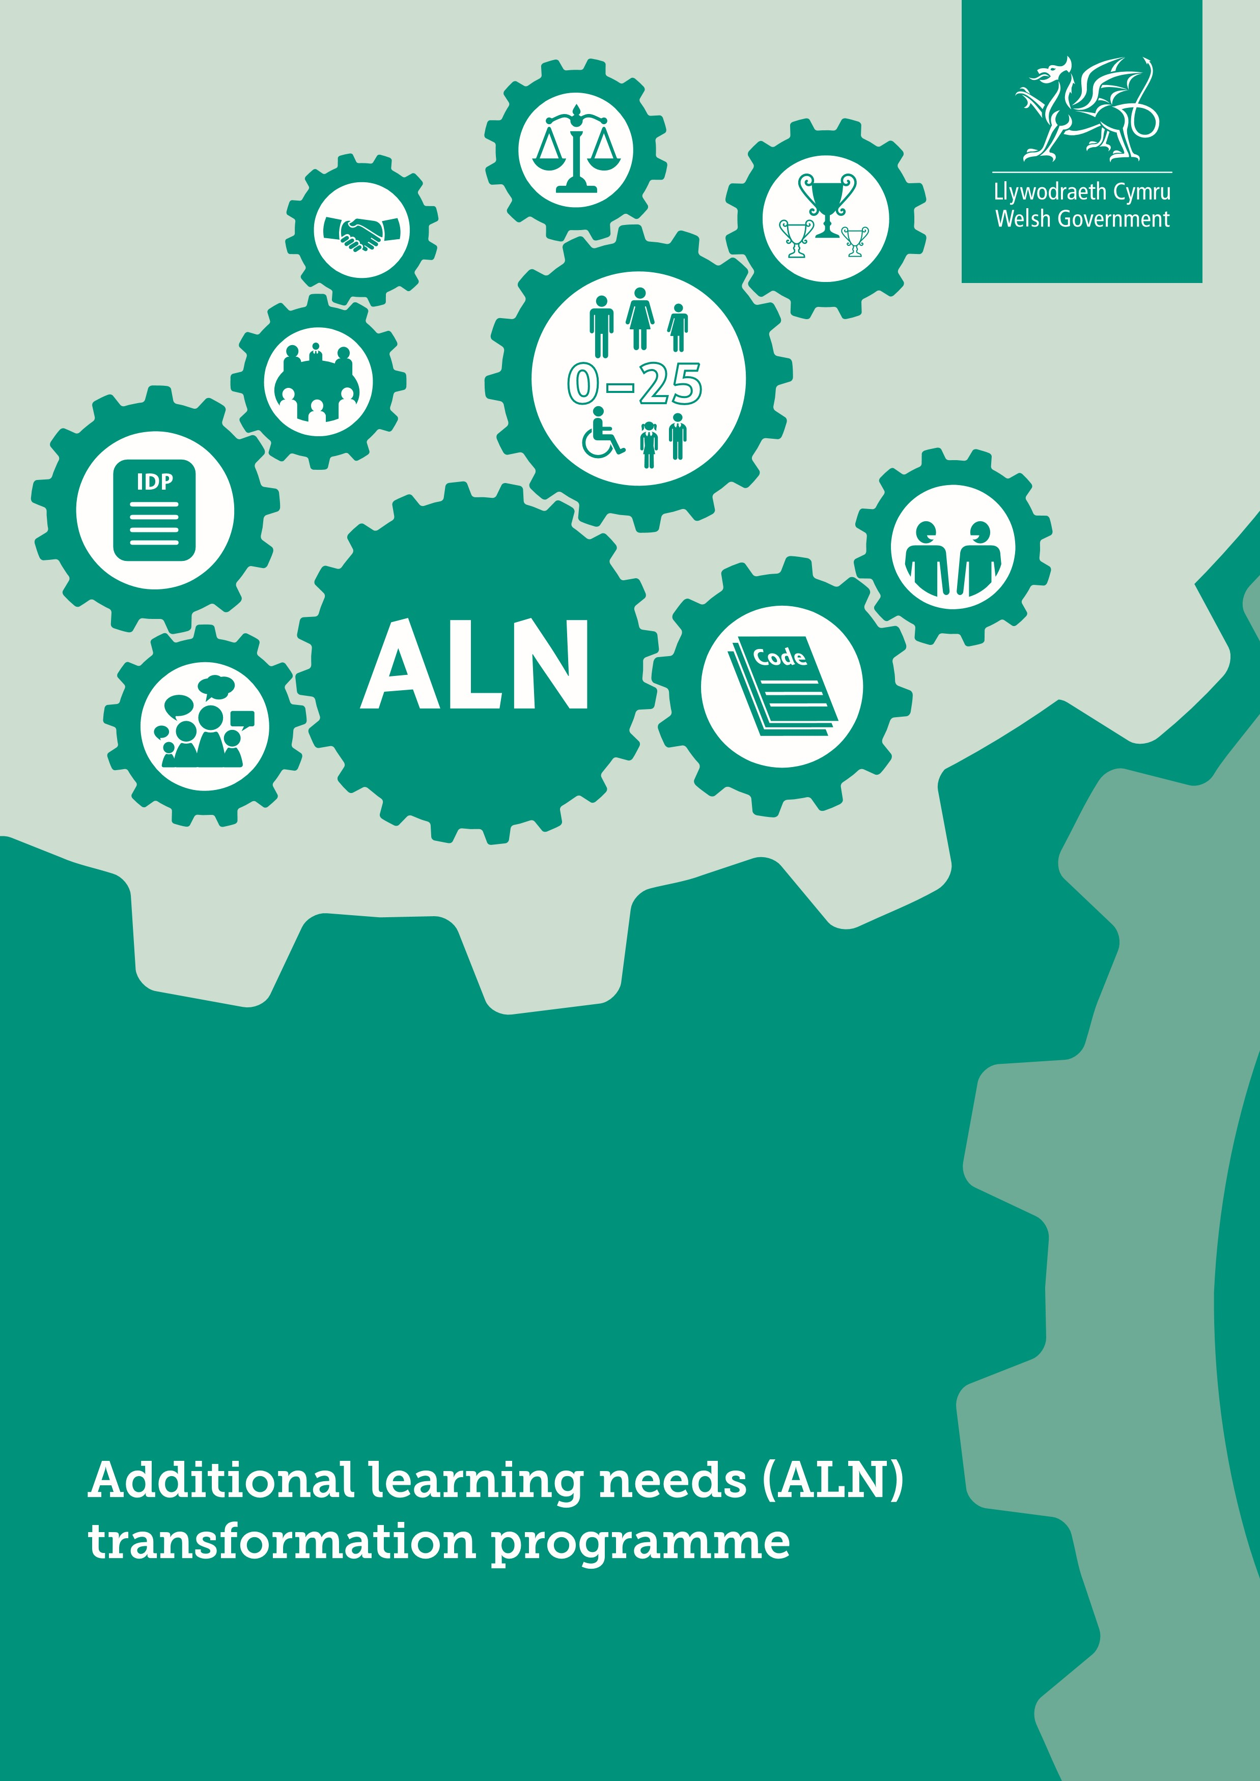
What’s changing?
We want to transform expectations, experiences and outcomes for children and young people with additional learning needs (ALN).
To do so, we have developed the Additional learning needs (ALN) transformation programme, which will transform the separate systems for special educational needs (SEN) in schools and learning difficulties and/or disabilities (LDD) in further education, to create a unified system for supporting learners from 0 to 25 with ALN.
The transformed system will:
- ensure that all learners with ALN are supported to overcome barriers to learning and can achieve their full potential
- improve the planning and delivery of support for learners from 0 to 25 with ALN, placing learners’ needs, views, wishes and feelings at the heart of the process
- focus on the importance of identifying needs early and putting in place timely and effective interventions which are monitored and adapted to ensure they deliver the desired outcomes.
New legislation and statutory guidance is only one aspect, albeit a fundamental one, of the wider package of reforms needed. The ALN transformation programme also focuses on skills development for the education workforce, to deliver effective support to learners with ALN in the classroom, as well as easier access to specialist support, information and advice.

Why it’s changing
We think it should be a right for all learners to have equity of access to education that meets their needs and enables them to participate in, benefit from and enjoy learning.
105,000 children, 22.6% of all learners at maintained schools in Wales, have SEN. Overall the academic attainment of learners with SEN is poor compared to the rest of the learner population.
The current system for supporting children and young people with SEN and learning difficulties and/or disabilities is based on a model introduced more than 30 years ago that is no longer fit for purpose.
Under the new system planning will be flexible and responsive, our professionals will be skilled and confident in identifying needs and deploying strategies to help learners overcome their barriers to learning, and the learner will be at the centre of everything we do.

How it’s changing
In order to effectively implement, support transition and deliver the new system, the ALN transformation programme will focus on the following five themes.

1. Legislation and statutory guidance
The Additional Learning Needs and Education Tribunal (Wales) Bill (ALNET Bill) was introduced to the National Assembly for Wales on Monday 12 December 2016. This will create the legislative framework to improve the planning and delivery of additional learning provision, through a person-centred approach to identifying needs early, putting in place effective support and monitoring and adapting interventions to ensure they deliver desired outcomes.
The Bill will be supported by:
- regulations – secondary legislation where further detail is required
- Additional Learning Needs (ALN) Code – statutory guidance and mandatory requirements to help people and organisations work within the law.

The 10 aims of the Bill
- The introduction of the term additional learning needs (ALN)
The Bill replaces the terms ‘special educational needs’ (SEN) and ‘learning difficulties and/or disabilities’ (LDD) with the new term ALN.
- A 0 to 25 age range
There will be a single legislative system relating to the support given to children and young people aged between 0 to 25 years who have ALN. This is instead of the two separate systems currently operating to support children and young people of compulsory school age who have SEN; and young people in further education who have LDD.
- A unified plan
The Bill will create a single statutory plan (the individual development plan (IDP)) to replace the existing variety of statutory and non-statutory SEN or LDD plans for learners in schools and further education.
- Increased participation of children and young people
The Bill requires that learners’ views should always be considered as part of the planning process, along with those of their parents/carers. It is imperative that children and young people see the planning process as something which is done with them rather than to them.
- High aspirations and improved outcomes
The emphasis of IDPs will be on making provision that delivers tangible outcomes that contribute in a meaningful way to the child or young person’s achievement of their full potential.
- A simpler and less adversarial system
The process of producing and revising an IDP should be much simpler than is currently the case with statements of SEN.
- Increased collaboration
The new system will encourage improved collaboration and information sharing between agencies, which are essential to ensuring that needs are identified early and the right support is put in place to enable children and young people to achieve positive outcomes.
3
- Avoiding disagreements and earlier disagreement resolution
The new system will focus on ensuring that where disagreements occur about an IDP or the provision it contains, the matter is considered and resolved at the most local level possible.
- Clear and consistent rights of appeal
Where disagreements about the contents of an IDP cannot be resolved at the local level, the Bill will ensure that children and young people entitled to an IDP (and their parents/carers in the case of those that are under 16 years) will have a right of appeal to a tribunal.
- ALN Code
The Code will ensure that the new ALN system has a set of clear, legally enforceable parameters within which local authorities and those other organisations responsible for the delivery of services for children and young people with ALN, must act.
2
. Workforce development

This is a programme of skills development for education practitioners focused at three levels.
- Core skills development for all practitioners to support a wide range of low complexity, high incidence ALN within settings/schools and access to ongoing professional development. This includes the roll-out of person-centred practice, which is a central aspect of our new approach, across all education settings/schools. We have provided a two-year funding grant to local authorities and further education institutions (FEIs) for developing person-centred practice skills across the workforce. Personcentred practice materials are available on Learning Wales (http://learning.gov.wales/ resources/browse-all/person-centred-practice-guide/?lang=en).
- Advanced skills development through the development of the role of additional learning needs coordinators (ALNCos), who will replace current special educational needs coordinators (SENCos).
- Specialist skills development through a national workforce planning system for local authority-provided specialist support services available to education settings/schools, e.g. educational psychologists and teachers of the visually or hearing impaired.

3. Implementation/transition support
To ensure successful and consistent implementation of the new system, we will be helping services to prepare for the changes ahead and to develop closer multi-agency and cross-sector working practices. This includes:
- ALN Innovation Funding: supporting regional partnership projects between local authorities, schools, FEIs, specialist providers, health, social services, early years and the third sector
- ALN Strategic Implementation Group: a joint working group between the Welsh
Government and local authorities, local health boards and the further education sector.
The Group will consider practical solutions and provide advice and recommendations to the Welsh Government to support implementation of the ALN transformation programme
- readiness, compliance and impact monitoring and evaluation: to ensure that implementation of the ALNET Bill is monitored closely, that issues are effectively addressed for the benefit of children and young people, and that best practice is being identified and shared across Wales. The approach will consider implementation in stages.
  - Readiness: assessing the extent to which local authorities and other delivery agents are prepared for the changes ahead.
  - Compliance: how effectively they are complying with the new legislative requirements once they take effect.
  - Impact: how and the extent to which the changes are embedding and making an impact on outcomes for learners.
- ALN Implementation Grants: funding to support delivery partners (including local authorities, FEIs, local health boards, the Tribunal and Estyn) to prepare for transition to the new system
- ALN Strategic Advisors: a small team of strategic advisors to provide advice, support and challenge to local authorities and other delivery partners in preparing for and managing transition to the new ALN system.
4
. Awareness raising

- Interactive materials to help all those in the system understand the evidence for best practice, what can be expected from interventions, the interventions that are likely to be most effective, and the role of professionals to help ensure realistic expectations and effective deployment of resources.
- Awareness-raising activities in preparation for implementation of the transformed system, focusing on engaging stakeholders about their new legislative duties, and explaining and promoting the system and the rights it confers to children, young people and parents/carers.
5
. Supporting policy

- Policy and guidance to ensure that good practice is supported and embedded in the current SEN system as well as the future ALN system.

When it’s changing
The ALNET Bill which was introduced to the National Assembly for Wales on
Monday 12 December 2016, will be subject to scrutiny by an Assembly committee.
5
They will then either agree or disagree to the general principles of the Bill or make recommendations for amendments to the Bill.
Once the Bill has been agreed by the committee and passed by the National Assembly for Wales it will then be submitted for Royal Assent. On receiving Royal Assent the Bill will become an Act of the Assembly and the new law may be commenced.
A draft of the ALN Code will be made available to support Assembly Members’ scrutiny of the Bill.
Following Royal Assent, the ALN Code and regulations which support the Act will then be revised (based on any recommendations for amendments) and consulted on, laid before the Assembly and published.
For the time being, local authorities and all those who work with children and young people with SEN, must ensure that they continue to comply with the duties placed upon them by the Education Act 1996. They must also continue to have regard to the SEN Code of Practice for Wales. The SEN Code of Practice can be accessed on Learning Wales (http://learning.gov.wales/resources/browse-all/special-education-needs-code-ofpractice/?lang=en).

Find out more

Online
Welsh Government – www.gov.wales/ALN
National Assembly for Wales – www.assembly.wales

Twitter
#additionallearningneeds

E-mail
Additional learning needs transformation programme, Welsh Government
SENreforms@wales.gsi.gov.uk

© Crown copyright 2017 WG31766 Digital ISBN: 978 1 4734 9453 4

