Protecting and improving the nation’s health

LIBERIA

GUINEA

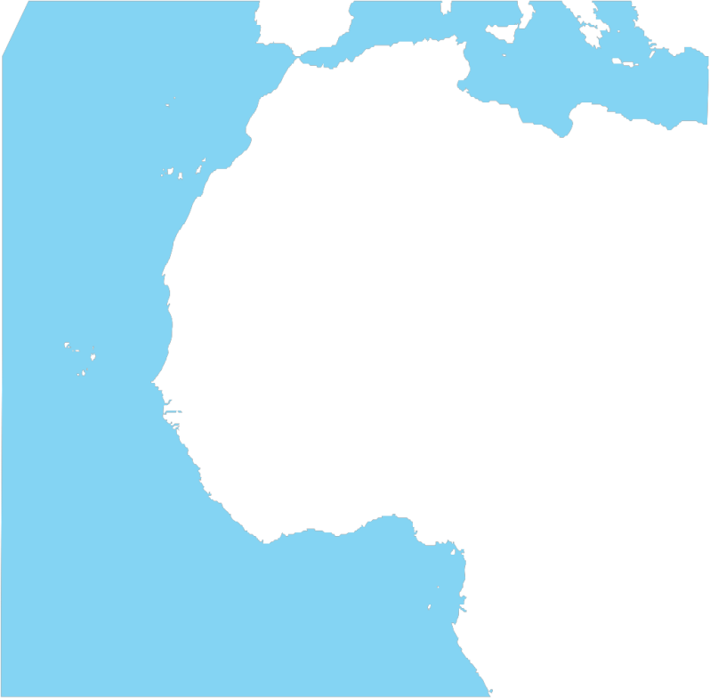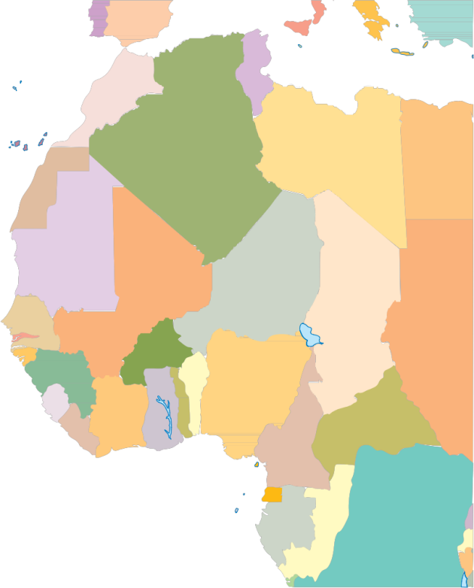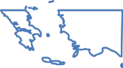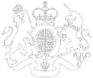

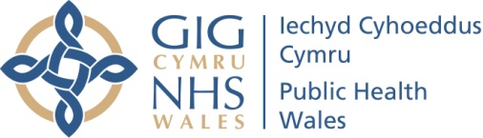

* The risk of Ebola is low for most travellers
* However, malaria is a much more common infection in West Africa and can have similar early symptoms. It is treatable if diagnosed quickly, so contact NHS Direct Wales (dial: 0845 46 47) for advice if you feel unwell
* If you are staying in the UK and develop symptoms such as  
  - fever (37.5˚C or higher)  
  - headache  
  - body aches  
  - diarrhoea  
  - vomiting  
  **within 21**  **days of returning** from Sierra Leone, Guinea or Liberia, you should contact NHS Direct Wales (dial: 0845 46 47) and tell them where you have travelled;

If you are in transit to Scotland, England or Northern Ireland, and develop these symptoms after arrival, you should contact the relevant number and tell them where you have travelled.

* Scotland: NHS 24 (dial: 111)
* England: NHS 111
* Northern Ireland: contact your GP or a local Emergency Department.

If you are in transit to another country and develop these symptoms after you have left the UK, you should seek immediate medical attention there.

SIERRA LEONE



For more information visit: [www.publichealthwales.org/ebola](http://www.publichealthwales.org/ebola), [www.gov.uk/phe](http://www.gov.uk/phe) or [www.nhs.uk/ebola](http://www.nhs.uk/%20ebola). For health advice, call NHS Direct Wales on 0845 46 47

Dychwelyd o Orllewin Affrica?  
**Gwybodaeth am Ebola**

There is a large Ebola outbreak going on at present in West Africa

Returning from West Africa?  
**Information about Ebola**

Protecting and improving the nation’s health



Mae achosion sylweddol o Ebola yn digwydd ar hyn o bryd yng Ngorllewin Affrica

* Mae’r perygl o Ebola yn isel i’r rhan fwyaf o deithwyr
* Fodd bynnag, mae malaria yn haint llawer mwy cyffredin yng Ngorllewin Affrica a gall y symptomau cynnar fod yn debyg. Mae’n bosibl ei drin gyda diagnosis cynnar, felly cysylltwch â Galw Iechyd Cymru (deialwch: 0845 46 47) am gyngor os ydych yn teimlo’n anhwylus
* Os ydych yn aros yn y DU ac yn datblygu symptomau fel   
  - tymheredd uchel (37.5˚C neu uwch)  
  - cur pen  
  - corff dolurus  
  - dolur rhydd  
  - chwydu  
  **o fewn 21 ar ôl dychwelyd** o Sierra Leone, Guinea neu Liberia, dylech gysylltu â Galw Iechyd Cymru (deialwch: 0845 46 47) a dywedwch wrthynt ble rydych wedi teithio;

Os ydych ar y ffordd i’r Alban, Lloegr a Gogledd Iwerddon, ac yn datblygu’r symptomau hyn ar ôl cyrraedd, dylech gysylltu â’r rhif perthnasol a dweud wrthynt ble rydych wedi teithio.

* Yr Alban: NHS 24 (deialwch: 111)
* Lloegr: NHS 111
* Gogledd Iwerddon: cysylltwch â’ch meddyg teulu neu i Adran Frys lleol.

Os ydych ar y ffordd i wlad arall ac yn datblygu’r symptomau hyn ar ôl gadael y DU, dylech gael sylw meddygol yno ar unwaith.

SIERRA LEONE

GUINEA

LIBERIA

Am fwy o wybodaeth ewch i: [www.iechydcyhoedduscymru.org/ebola](http://www.iechydcyhoedduscymru.org/ebola), [www.gov.uk/phe](http://www.gov.uk/phe) neu [www.nhs.uk/ebola](http://www.nhs.uk/ebola).

Am gyngor iechyd, ffoniwch Galw Iechyd Cymru ar 0845 46 47